New Payment Module (NPM) Parallel Run Documentation
This document present the parallel run plan and the architecture of the initial release of the new payment module (NPM) version 1.0. The approach is to have a cut-off date when the system will be put into operation alongside with the existing system.

System architecture design

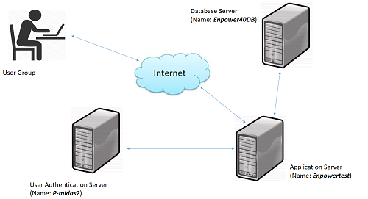

Datebase Server: The NPM database will be residence on Enpower40DB server.
Application Server: The NPM application files and user request will be processed and served back to the users through the internet. Microsoft IIS 8.0 application server on Enpowertest server machine will be responsible for these services. Also all the scanned and attached documents received from the application will be kept in the application folder called (“ApplicationDocuments”) in the same server machine (Enpowertest).
User Authentication server: User authentication and authorization is one of the key features of the application. The domain authentication functionality is achieved by the ingestion of an existing web service running on p-midas2 server machine.

Application Dependencies
The NPM highly dependent on Enpower4.0 application for retrieval of customer details and also update of some information if required. The dependent objects are listed below;
Dependent database name: Enpowerv4
Tables Name:
- Insurer (Read)
- Employer (Read)
- Employee (Read & Write : Update the insurerID and bank details as adjusted on NPM)
- NextOfKin (Read)
- Contribution (Read)
- ContributionType (Read)
- Titles (Read)
- UnitPrice (Read)
- Banks (Read)
- Bank Branches (Read)
- TempPayment (Write)
Stored Functions:
- udfGetBalanceBySource
- GetFundBalanceByDate
- udfGetWithdrawalsBF

Dependent Services:
The service name is “webService” and is running Microsoft IIS on P-MIDAS Server machine. The service is used for user domain authentication
Release Note:
The following are the major currently available features for the initial release of NPM
- Auto generation of file number and application code
- Ability to log application any location and scan to add/remove application documents.
- Auto generation of SNR forms
- Automation of SP logs
- Ability to step backward or step forward the application process at any stage of the application.
- Auto generation of payment schedule to be sent to the PFC.
- Auto-sweep of payment schedule into EnpowerV4 for unit cancellation
- Auto generation of hardcopy Application slip and softcopy to be sent to the customer through email
- Ability to Log hardcopy application(i.e. application that will not be sent to the regulator through RMAS)
- Ability to generate RMAS benefit application schedule and confirmation module for approval before submission to the regulator through RMAS is done(i.e. application that will be submitted on RMAS)
- A user management module for role allocation and de-allocation.

